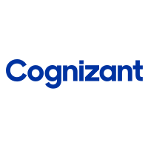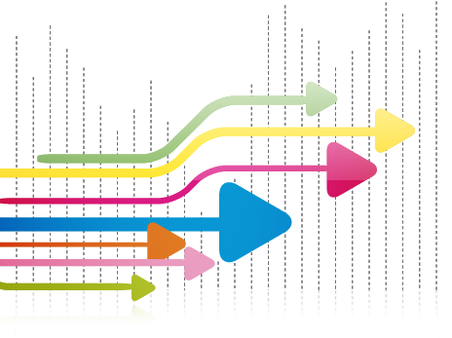

**BANALYST**

**Professional Summary**

A self-motivated innovative IT professional with 0.5 years of experience in Hadoop Hive and Big Data technologies and Life Sciences Domain. I involved in requirement gathering phase, migrating data them from **Teradata** to **Hive** database of **Cloudera** distribution and executing test cases. Hands on experience in Machine learning projects as well and proficient in **Python** and **Data Analysis**. In addition, have experience in writing stories, epic and participating in analytics workshops. Good record of accomplishment of finishing assigned tasks within time and have ability to work with minimal guidance.

* As part of my assignments, involved in IAE Franchise/product development work where we converted the SAS query to **Hive SQL** and migrating the tables from Teradata to Cloudera.
* Involved in **Sqooping** tables from Teradata to Hadoop Hive.
* Strong expertise in **Data Analytics, In-Depth Exploratory Data Analysis.**
* Insight Generation and Data processing using **Python** and Reporting using **Tableau**.
* Always thrive to learn new technologies and interest in Data Analytics.
* Strong verbal/written communication in presentation skills, including an ability to communicate effectively with team.

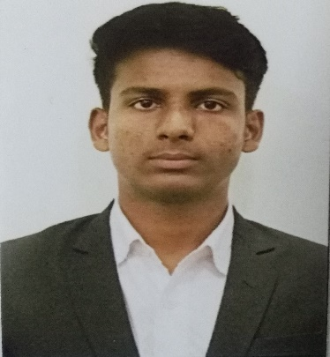

### Aeturi Anvesh

### Programmer Analyst

### Mobile: +91-9041025418

Aeturi.Anvesh@cognizant.com

**Key Competency Areas**

* SparkSQL
* Hadoop Hive
* Pyspark
* Python
* SQL
* Excel
* Exploratory Data Analysis
* Statistical Knowledge
* Machine Learning
* Exposure in Tableau
* GIT

**Key Projects and Responsibilities**

**Project 1:**

**Client: AbbVie**

**Title: AbbVie -AIA Brand Tech T&M 202**

**Project Objective**

The Brand Tech T&M project is Data Migration project. The responsibility of the Intelligent Decision Platform(IDP) is responsible for designing, building and operating data to identify data driven insights that can be shared across ecosystem to orchestrate sales and marketing touch. In regular work we are migrating the data from Teradata to Hive database of Cloudera distribution. And we create six output files on top of each Franchise/Product. The purpose of this project is to provide input data files from HCP360- CDL. Files are consumed into Pega suggestion Engine.

**Responsibilities**

* As Big Data Developer I was working on Hadoop Hive, Sqooping, SparkSQL.
* Documentation, writing test cases, performing functional and manual testing.

**Personal Project: [**[**Find Here**](https://github.com/AnveshAeturi?tab=projects)**]**

**Title: To Predict School Project Funding Chances**

**Project Objective**

Donors chooses non-profit organization, where public school teacher from every corner of America create classroom project requests in *donorschoose.org*, which is in need and any user can give any amount to the project that inspires them. The project was to find the chances of project being funded on given features which contain categorical, text and numerical.

**Responsibilities**

* Collecting data from **Kaggle** and perform data pre-processing into sub categories.
* By feature-engineering and creating new features like **Sentiment Score** on project essay using Sentiment Intensity Analyser, Number of words in Title and Essay etc.
* Vectorizing text data using **BOW**, **TF-IDF**, **AVG weighted W2V**.
* Building different machine learning models on top of each vectorizer by performing Hyper-parameter tuning, and training on best Hyper-parameter.
* Displaying the results of trained model on test data using confusion matrix.

**Education**

**B. Tech** in Electronics and Communication Engineering **(Honors)**,

**Minored in Data Science**

Lovely Professional University, Punjab.

**Trainings & Certifications**

* Applied Machine Learning Course
* Machine Learning A-Z Hands on Python in Data Science
* The Complete PythonBootcamp

**Achievements**

* Awarded 2nd prize in Innovation award in 67th Mile Stone BML Munjal University, Gurgaon